

CLASS: BCA 5th Sem
Batch: 2018-21
Project Report
ON
HOSPITAL MANAGEMENT SYSTEM

Submitted To: Submitted By:
Ms. Sushma Jassaar Name : Chandan Kumar
Class : BCA 5th
Roll No .: 1829105

PREFACE

This project “HOSPITAL MANAGEMENT SYSTEM” provides a simple interface, that enables a manufacturing industry to schedule its manufacturing operations based on the daily update of sales from its dealers. Once the sales figures of items for the past week are entered by the dealers over the internet along with the orders for the next delivery, the schedule for the next week’s production will be drawn up. A report of the required raw materials or parts will be drawn up with the product requirements over the internet & asked to quote their rates. The project provides facilities like online registration and profile creation of by visitors and posting new topics in form of queries by them. Various categories based on the user’s interest can be created by the Administrator of the forums.
The Benefits of the Stores Management System is
- It is used as an intranet Application.
- Providing High-Security.
- Easy Business Solutions.
Stores are required for the following purposes :-
- Capital works
- Operation and Maintenances Works
- Other Commercial activities like hiring equipment etc.

ACKNOWLEDGEMENT

I take this opportunity to express my sincere gratitude to all those who helped me in undertaking this project and devising the report.

I privileged to express MY sense of gratitude to Ms Sushma, for the brainwave and encouragement given and for providing me the opportunity to commence my project.

I am highly indebted to MS. Sushma for giving me a rare opportunity to undertake this project. I am also grateful to all my team members involved in this project.

Name of Student
Chandan Kumar

TABLE OF CONTENTS

  - Introduction to project / Project Description.
  - Requirement Analysis.
  - Feasibility Study (Technical, Economical and Behavioral ).
  - Project Design.
  - Use case model.
  - E-R Diagram.
  - Data Flow Diagram.
  - UML Diagram.
  - Module Description.
  - Validation Checks.
  - Tools and Platform.
  - Coding and Screens.
  - Testing.
  - Implementation and Maintenance.
  - Nature and Future scope of Project.
  - Bibliography.

WHAT IS SOFTWARE PROJECT

pattern of an IT company engaged in software development can be seen split in two parts:
- Software Creation
- Software Project Management
A project is well-defined task, which is a collection of several operations done in order to achieve a goal (for example, software development and delivery).
A Project can be characterized as:
- Every project may has a unique and distinct goal.
- Project is not routine activity or day-to-day operations.
- Project comes with a start time and end time.
- Project ends when its goal is achieved hence it is a temporary phase in the lifetime of an organization.
- Project needs adequate resources in terms of time, manpower, finance, material and knowledge-bank.
A Software Project is the complete procedure of software development from requirement gathering to testing and maintenance, carried out according to the execution methodologies, in a specified period of time to achieve intended software product.
You just need to drag and drop any graphical object anywhere on the form and click on the object to enter the code window and start programming.
The job

Need of software project management

Software is said to be an intangible product. Software development is a kind of all new stream in world business and there’s very little experience in building software products. Most software products are tailor made to fit client’s requirements. The most important is that the underlying technology changes and advances so frequently and rapidly that experience of one product may not be applied to the other one. All such business and environmental constraints bring risk in software development hence it is essential to manage software projects efficiently.
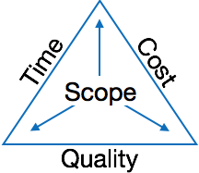
The image above shows triple constraints for software projects. It is an essential part of software organization to deliver quality product, keeping the cost within client’s budget constrain and deliver the project as per scheduled. There are several factors, both internal and external, which may impact this triple constrain triangle. Any of three factor can severely impact the other two.

What Is Visual Basic and Why do I need it?

Visual Studio Code combines the simplicity of a source code editor with powerful developer tooling, like IntelliSense code completion and debugging.
First and foremost, it is an editor that gets out of your way. The delightfully frictionless edit-build-debug cycle means less time fiddling with your environment, and more time executing on your ideas.

Customize every feature to your liking and install any number of third-party extensions. While most scenarios work "out of the box" with no configuration, VS Code also grows with you, and we encourage you to optimize your experience to suit your unique needs. VS Code is an open-source project so you can also contribute to the growing and vibrant community on GitHub.

The Advantages of Visual Studio Code:

It's simple language. Things that may be difficult to program with other language can be done in Visual Studio Code very easily.
Because Visual Studio Code is so popular, There are many good resources (Books, Web sites, News groups and more) that can help you learn the language. You can find the answers to your programming problems much more easily than other programming languages.
You can find many tools (Sharewares and Freewares) on the internet that will Spare you some programming time.
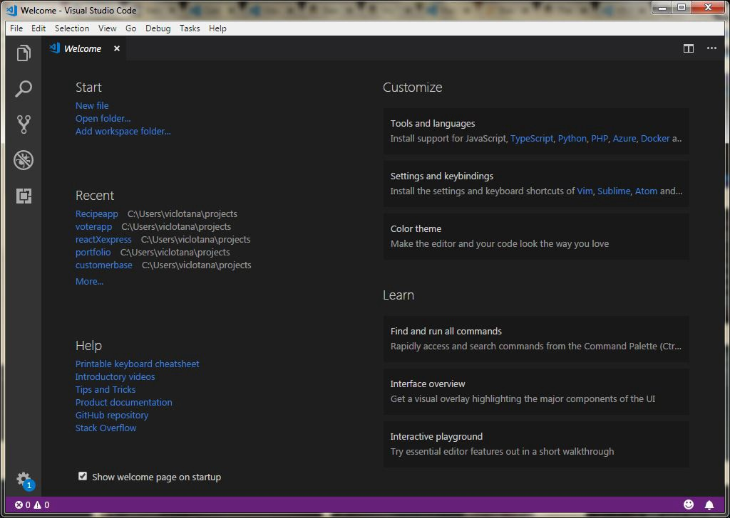
You can choose to either start a new project, open an existing project or select a list of recently opened programs. A project is a collection of files that make up your application. There are various types of applications that we could create, however, Before you begin, you must think of an application that might be useful, have commercial values . educational or recreational. click on the Standard EXE icon to go into the actual Visual Studio Code programming environment.
When you start a new Visual Studio Code project, you will be presented with the Visual Studio Code Integrated Development Environment (IDE). The Visual Studio Code Integrated Programming Environment It consists of the Extensions, the form, the project explorer and the properties window.
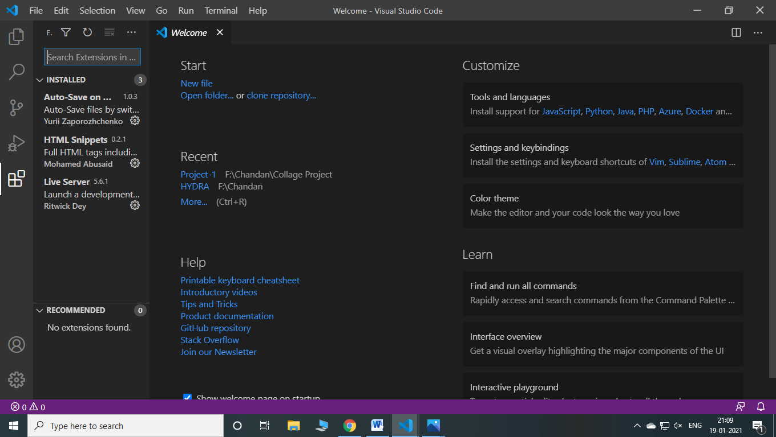

PROJECT DESCRIPTION

Introduction :
Hospital Management System is aimed at reducing paper work for a hospital and hence improving its efficiency and speeding up of all processes.
Hence, all the related information about a patient is available to Hospital, WeCare’s, reception staff (for bill processing), etc. Thus this software saves the entire patient’s hassle.

Moreover, all the information regarding an employee is available to the administration and hence his salary can be worked out easily. Thus it avoids employees’ trouble.

Features :

- Employee registration and management.
- Patient registration and management.
- Lab reports handling.
- Manage patient bills.
- Patient’s appointment handling.

CODING AREA

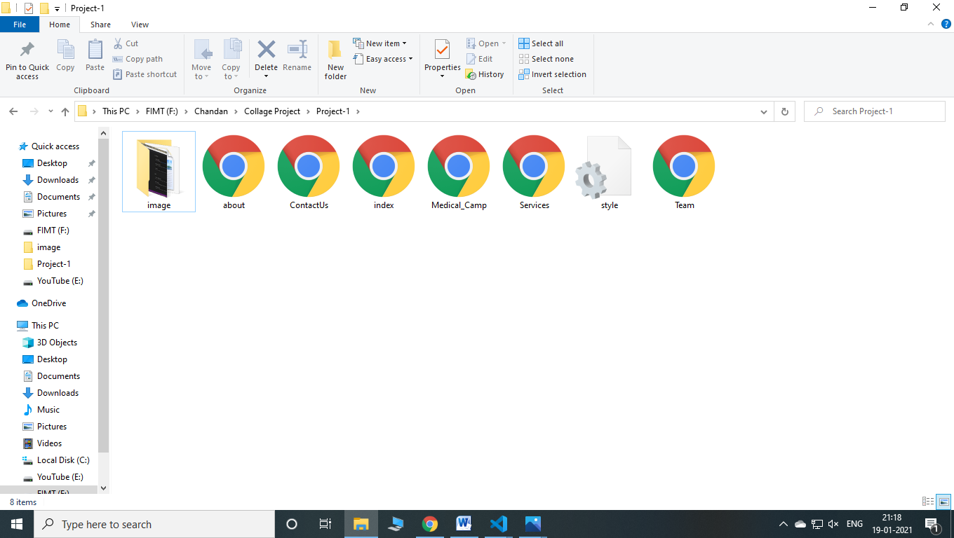

Login Page of WeCare’s Hospital
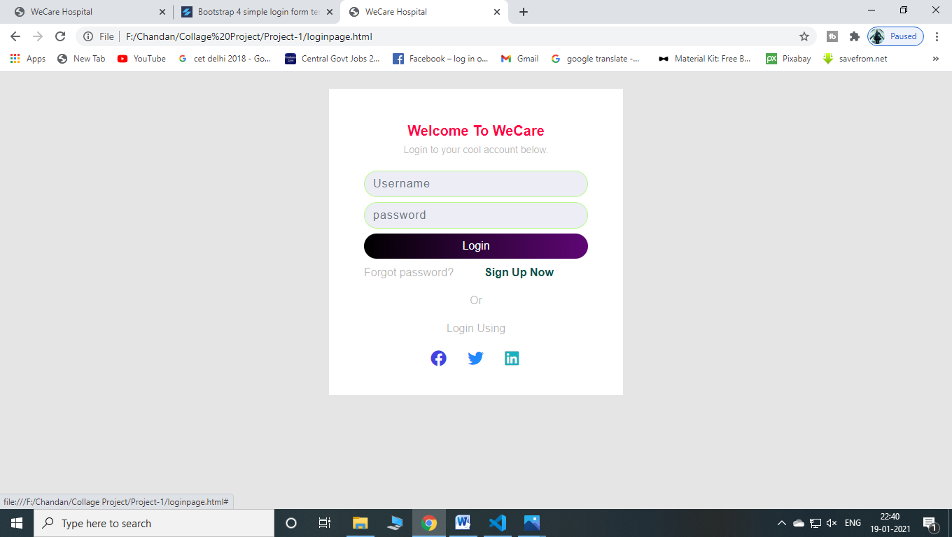
Coding:
<!--Login Page-->
<div class="container">
<div class="row">
<div class="col-md-6 mx-auto py-4 px-0">
<div class="card p-0">
<div class="card-title text-center">
<h5 class="mt-5">Welcome To WeCare</h5> <small class="para">Login to your cool account below.</small>
</div>
<form class="signup">
<div class="form-group"><input type="text" class="form-control" placeholder="Username"></div>
<div class="form-group"><input type="password" class="form-control" placeholder="password"></div><a href="index.html"> <button type="button" class="btn btn-primary">Login</button></a>
<div class="row">
<div class="col-6 col-sm-6"> <a href="#">
<p class="text-left pt-2 ml-1">Forgot password?</p>
</a> </div>
<div class="col-6 col-sm-6"> <a href="#">
<p class="text-right pt-2 mr-1">Sign Up Now</p>
</a> </div>
</div> <span class="text-center">Or</span> <span class="text-center pt-3">Login Using</span>
<div class="row">
<div class="d-flex mx-auto pt-1 pb-3"> <a href="#"><i class="fab fa-facebook"></i></a> <a href="#"><i class="fab fa-twitter"></i></a> <a href="#"><i class="fab fa-linkedin"></i></a> </div>
</div>
</form>
</div>
</div>
</div>
</div>
<!--End of Login Page-->

First Page

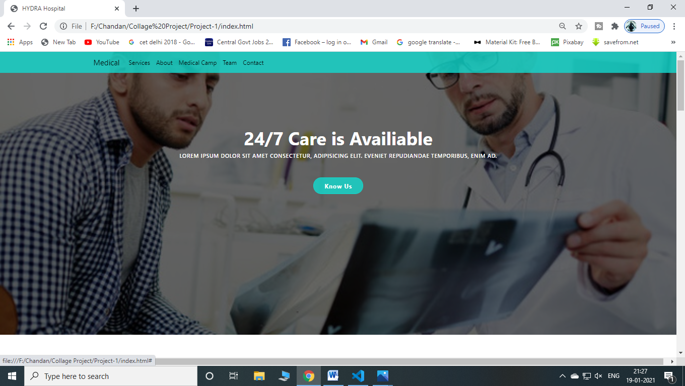
Coding :
<!--nav bar-->
<nav class="navbar navbar-expand-lg nav-back fixed-top" id="nav">
<div class="container">
<a href="index.html" class="navbar-brand">Medical</a>
<button class="navbar-toggler navbar-toggler-right" type="button"
data-toggle="collapse" data-target="#myNavbar" aria-controls="myNavbar"
aria-expanded="false" aria-label="Toggle navigation">
<i class="fas fa-syringe fa-2x"></i>
</button>

<div class="collapse navbar-collapse" id="myNavbar">
<ul class="navbar-nav ml-auto">
<li class="nav-item">
<a href="services.html" class="nav-link">Services</a>
</li>

<li class="nav-item">
<a href="about.html" class="nav-link">About</a>
</li>

<li class="nav-item">
<a href="Medical_Camp.html" class="nav-link">Medical Camp</a>
</li>

<li class="nav-item">
<a href="Team.html" class="nav-link">Team</a>
</li>

<li class="nav-item">
<a href="ContactUs.html" class="nav-link">Contact</a>
</li>
</ul>
</div>
</div>
</nav>
<!--End of nav bar-->
<!--Hero image-->
<section id="hero" class="d-flex align-item-center">
<div class="container text-center position-relative">
<h1>24/7 Care is Availiable</h1>
<h2 class="text-uppercase">Lorem ipsum dolor sit amet consectetur, adipisicing elit.
Eveniet repudiandae
temporibus, enim ad.</h2>
<a href="#" class="main-btn">Know Us</a>
</div>
</section>
<!--End of Hero image-->

Page-2 Services :
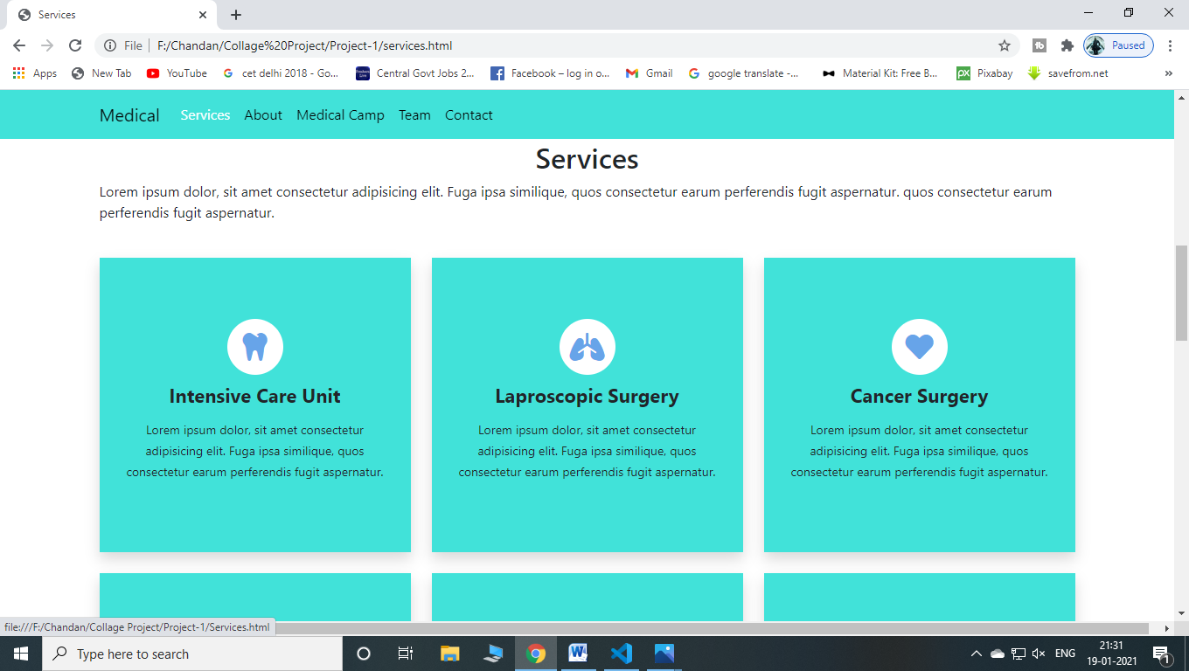

Coding:
<!--Services-->
<section id="services" class="services mt-5 mb-3f py-3">
<div class="container">
<div class="section-title">
<h2 class="text-center">Services</h2>
<p>Lorem ipsum dolor, sit amet consectetur adipisicing elit. Fuga ipsa similique,
quos consectetur earum perferendis fugit aspernatur.
quos consectetur earum perferendis fugit
aspernatur.
</p>
</div>
<div class="row">
<!---->
<div class="col-lg-4 col-md-6 d-flex align-items-stretch mt-4">
<div class="service shadow">
<div class="icon">
<i class="fas fa-tooth"></i>
</div>
<h4>Lorem Ipsum </h4>
<p>Lorem ipsum dolor, sit amet consectetur adipisicing elit.
Fuga ipsa similique,
quos consectetur earum perferendis fugit aspernatur.</p>
</div>
</div>
<!---->
<!---->
<div class="col-lg-4 col-md-6 d-flex align-items-stretch mt-4">
<div class="service shadow">
<div class="icon">
<i class="fas fa-lungs"></i>
</div>
<h4>Lorem Ipsum </h4>
<p>Lorem ipsum dolor, sit amet consectetur adipisicing elit.
Fuga ipsa similique,
quos consectetur earum perferendis fugit aspernatur.</p>
</div>
</div>
<!---->

<!---->
<div class="col-lg-4 col-md-6 d-flex align-items-stretch mt-4">
<div class="service shadow">
<div class="icon">
<i class="fas fa-heart"></i>
</div>
<h4>Lorem Ipsum </h4>
<p>Lorem ipsum dolor, sit amet consectetur adipisicing elit.
Fuga ipsa similique,
quos consectetur earum perferendis fugit aspernatur.</p>
</div>
</div>
<!---->
<!---->
<div class="col-lg-4 col-md-6 d-flex align-items-stretch mt-4">
<div class="service shadow">
<div class="icon">
<i class="fas fa-dna"></i>
</div>
<h4>Lorem Ipsum </h4>
<p>Lorem ipsum dolor, sit amet consectetur adipisicing elit.
Fuga ipsa similique,
quos consectetur earum perferendis fugit aspernatur.</p>

</div>
</div>
<!---->
<!---->
<div class="col-lg-4 col-md-6 d-flex align-items-stretch mt-4">
<div class="service shadow">
<div class="icon">
<i class="fas fa-ambulance"></i>
</div>
<h4>Lorem Ipsum </h4>
<p>Lorem ipsum dolor, sit amet consectetur adipisicing elit.
Fuga ipsa similique,
quos consectetur earum perferendis fugit aspernatur.</p>

</div>
</div>
<!---->
<!---->
<div class="col-lg-4 col-md-6 d-flex align-items-stretch mt-4">
<div class="service shadow">
<div class="icon">
<i class="fas fa-allergies"></i>
</div>
<h4>Lorem Ipsum </h4>
<p>Lorem ipsum dolor, sit amet consectetur adipisicing elit.
Fuga ipsa similique,
quos consectetur earum perferendis fugit aspernatur.</p>

</div>
</div>
<!---->
</div>
</div>
</section>
<!--End of Services-->

Page-3 About :
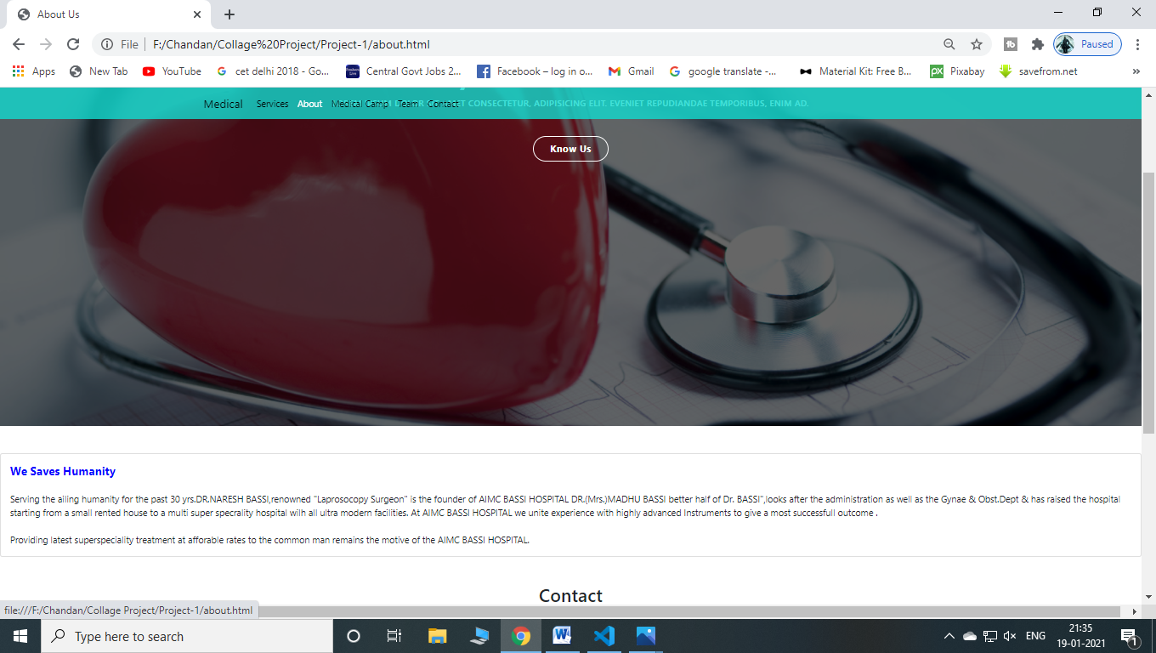

Coding:
<!--something about hospital-->
<div class="card mt-5">
<div class="card-body">
<span style="color: blue; font-weight:bold; font-size:20px;" >We Saves Humanity<br></span>
<br>
Serving the ailing humanity for the past 30 yrs.DR.NARESH BASSI,renowned "Laprosocopy Surgeon" is the founder of AIMC BASSI HOSPITAL DR.(Mrs.)MADHU BASSI better half of Dr. BASSI",looks after the administration as well as the Gynae & Obst.Dept & has raised the hospital starting from a small rented house to a multi super specrality hospital wilh all ultra modern facilities. At AIMC BASSI HOSPITAL we unite experience with highly advanced Instruments to give a most successfull outcome .
<br><br>
Providing latest superspeciality treatment at afforable rates to the common man remains the motive of the AIMC BASSI HOSPITAL.
</div>
</div>

<div class="about-text2">
<div class="row"></div>
</div>
<!--end of something about hospital-->

Page-4 Medical Camp:

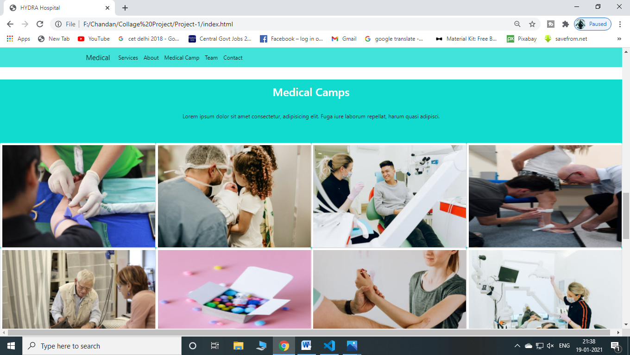

Coding:

<!--Camps section-->
<section class="camp">
<div class="container">
<h2 class="py-3">Medical Camps</h2>
<p style="text-align: center;">Lorem ipsum dolor sit amet consectetur,
adipisicing elit. Fuga iure laborum repellat, harum quasi adipisci.</p>
</div>
<div class="camp-grid">
<div class="row">
<!---->
<div class="col-lg-3 col-sm-6 col-xs-12">
<div class="card card-block">
<img src="./image/camp3.jpeg">
<div class="camp-text">
<div>
<h2 class="card-title" style="margin-top: 90px;">Lorem Ipsum</h2>
<p class="card-text">Lorem ipsum dolor sit, amet consectetur
adipisicing elit.</p>
</div>
</div>
</div>
</div>
<!---->
<!---->
<div class="col-lg-3 col-sm-6 col-xs-12">
<div class="card card-block">
<img src="./image/camp4.jpeg">
<div class="camp-text">
<div>
<h2 class="card-title" style="margin-top: 90px;">Lorem Ipsum</h2>
<p class="card-text">Lorem ipsum dolor sit, amet consectetur
adipisicing elit.</p>
</div>
</div>
</div>
</div>
<!---->
<!---->
<div class="col-lg-3 col-sm-6 col-xs-12">
<div class="card card-block">
<img src="./image/camp9.jpeg">
<div class="camp-text">
<div>
<h2 class="card-title" style="margin-top: 90px;">Lorem Ipsum</h2>
<p class="card-text">Lorem ipsum dolor sit, amet consectetur
adipisicing elit.</p>
</div>
</div>
</div>
</div>
<!---->
<!---->
<div class="col-lg-3 col-sm-6 col-xs-12">
<div class="card card-block">
<img src="./image/camp10.jpeg">
<div class="camp-text">
<div>
<h2 class="card-title" style="margin-top: 90px;">Lorem Ipsum</h2>
<p class="card-text">Lorem ipsum dolor sit, amet consectetur
adipisicing elit.</p>
</div>
</div>
</div>
</div>
<!---->
</div>
</div>
</section>
<!--End of camps section-->

Form5:

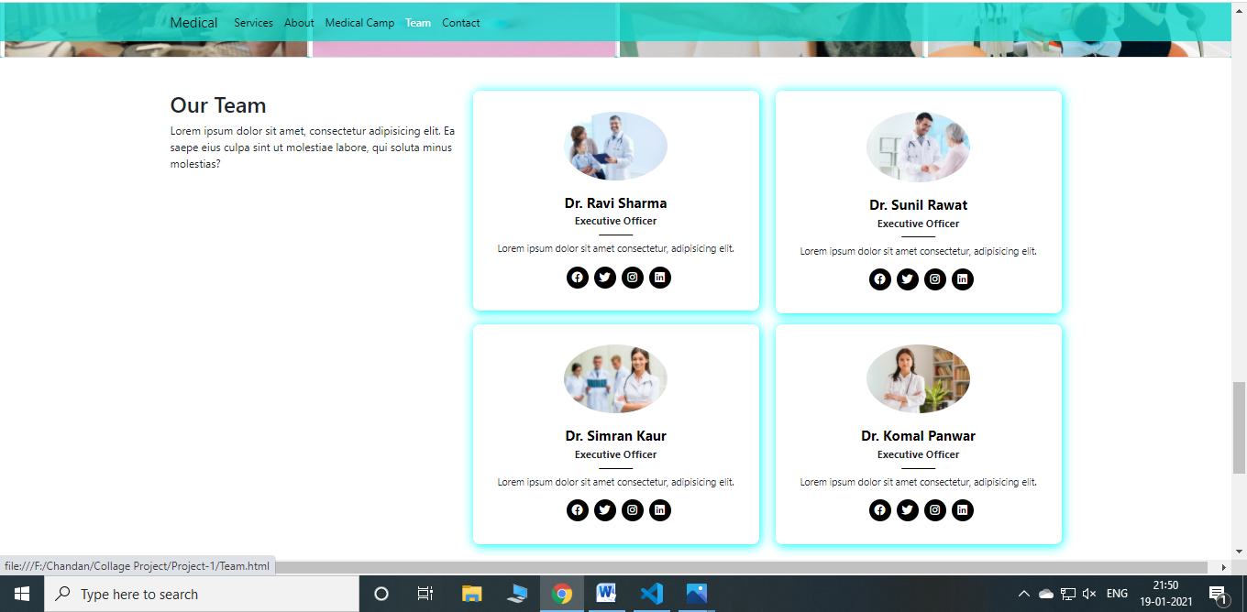

Coding:

<!--Team section-->
<section id="team" class="team mt-5">
<div class="container">
<div class="row">
<div class="col-lg-4">
<div class="section-title">
<h2>Our Team</h2>
<p>Lorem ipsum dolor sit amet, consectetur adipisicing elit.
Ea saepe eius culpa sint ut molestiae labore, qui soluta minus
molestias?</p>
</div>
</div>
<div class="col-lg-8">
<div class="row">
<!---->
<div class="col-lg-6">
<div class="member">
<div class="image">
<img src="./image/team1.jpg" class="img-fluid" alt="">
</div>
<div class="info">
<h4>Dr. Ravi Sharma</h4>
<span>Executive Officer</span>
<p>Lorem ipsum dolor sit amet consectetur, adipisicing elit.</p>
<div class="social">
<a href="#">
<i class="fab fa-facebook"></i>
</a>
<a href="#">
<i class="fab fa-twitter"></i>
</a>
<a href="#">
<i class="fab fa-instagram"></i>
</a>
<a href="#">
<i class="fab fa-linkedin"></i>
</a>
</div>

</div>
</div>
</div>
<!---->
<!---->
<div class="col-lg-6 mt-4 mt-lg-0">
<div class="member">
<div class="image">
<img src="./image/team2.jpg" class="img-fluid" alt="">
</div>
<div class="info">
<h4>Dr. Sunil Rawat</h4>
<span>Executive Officer</span>
<p>Lorem ipsum dolor sit amet consectetur, adipisicing elit.</p>
<div class="social">
<a href="#">
<i class="fab fa-facebook"></i>
</a>
<a href="#">
<i class="fab fa-twitter"></i>
</a>
<a href="#">
<i class="fab fa-instagram"></i>
</a>
<a href="#">
<i class="fab fa-linkedin"></i>
</a>
</div>

</div>
</div>
</div>
<!---->
<!---->
<div class="col-lg-6 mt-4 mt-lg-3">
<div class="member">
<div class="image">
<img src="./image/team3.jpg" class="img-fluid" alt="">
</div>
<div class="info">
<h4>Dr. Simran Kaur</h4>
<span>Executive Officer</span>
<p>Lorem ipsum dolor sit amet consectetur, adipisicing elit.</p>
<div class="social">
<a href="#">
<i class="fab fa-facebook"></i>
</a>
<a href="#">
<i class="fab fa-twitter"></i>
</a>
<a href="#">
<i class="fab fa-instagram"></i>
</a>
<a href="#">
<i class="fab fa-linkedin"></i>
</a>
</div>

</div>
</div>
</div>
<!---->
<!---->
<div class="col-lg-6 mt-4 mt-lg-3">
<div class="member">
<div class="image">
<img src="./image/team4.jpg" class="img-fluid" alt="">
</div>
<div class="info">
<h4>Dr. Komal Panwar</h4>
<span>Executive Officer</span>
<p>Lorem ipsum dolor sit amet consectetur, adipisicing elit.</p>
<div class="social">
<a href="#">
<i class="fab fa-facebook"></i>
</a>
<a href="#">
<i class="fab fa-twitter"></i>
</a>
<a href="#">
<i class="fab fa-instagram"></i>
</a>
<a href="#">
<i class="fab fa-linkedin"></i>
</a>
</div>

</div>
</div>
</div>
<!---->
</div>
</div>
</div>
</div>
</section>
<!--End of Team section-->

Page-6 Contact Us:

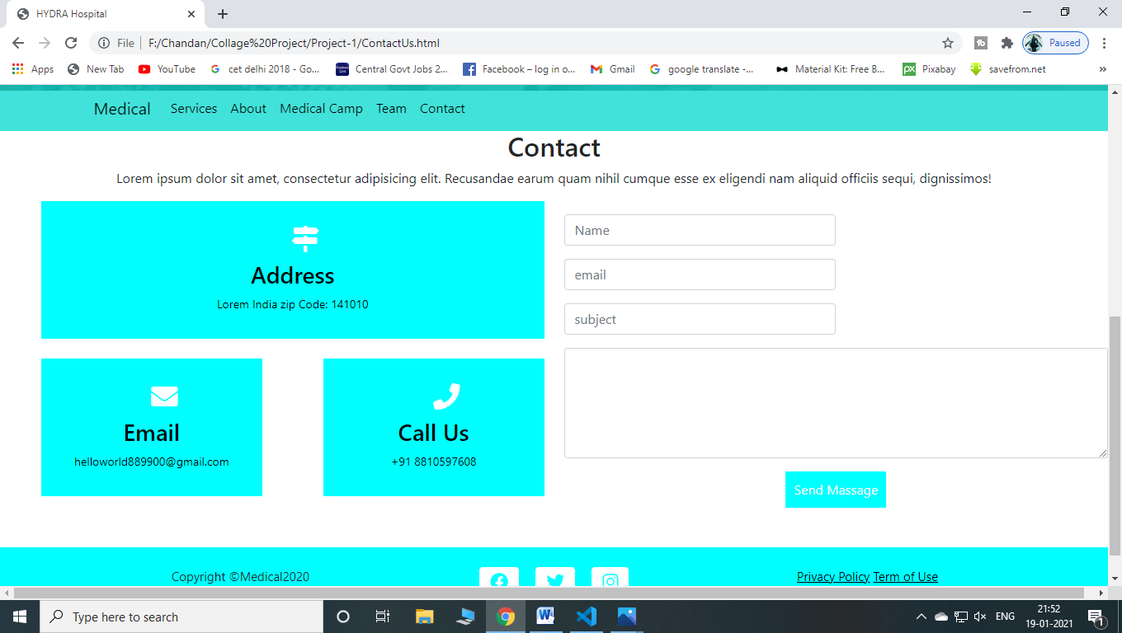

Coding:

<!--Contact section-->
<section class="contact">
<div class="contaier">
<div class="section-title text-center mt-5">
<h2>Contact</h2>
<p>Lorem ipsum dolor sit amet, consectetur adipisicing elit.
Recusandae earum quam nihil cumque esse ex eligendi nam aliquid officiis sequi,
dignissimos!</p>
</div>
<div class="row">
<div class="col-lg-6">
<div class="row">
<div class="col-md-12">
<div class="contact-box">
<i class="fas fa-map-signs"></i>
<h3>Address</h3>
<p>Lorem India zip Code: 141010</p>
</div>
</div>
<div class="col-md-6">
<div class="contact-box mt-4">
<i class="fas fa-envelope"></i>
<h3>Email</h3>
<p>helloworld889900@gmail.com</p>
</div>
</div>
<div class="col-md-6">
<div class="contact-box mt-4">
<i class="fas fa-phone"></i>
<h3>Call Us</h3>
<p>+91 8810597608</p>
</div>
</div>
</div>
</div>
<div class="col-lg-6">
<form>
<div class="form-row">
<div class="col-md-6 form-group">
<input type="text" name="name" class="form-control mt-3" id="name" placeholder="Name" >
</div>

<div class="col-md-6 form-group d-flex">
<input type="email" class="form-control mt-3" name="email" id="email" placeholder="email">

</div>

<div class="col-md-6 form-group">
<input type="text" class="form-control mt-3" name="subject" id="subject" placeholder="subject">
</div>

<div class=" form-group">
<textarea class="form-control mt-3" name="massage" rows="5"></textarea>
</div>

<div class="text-center mt-3">
<button type="submit">Send Massage</button>
</div>
</form>
</div>
</div>
</div>
</section>
<!--End of contact section-->

Page-7 Booking Appointment

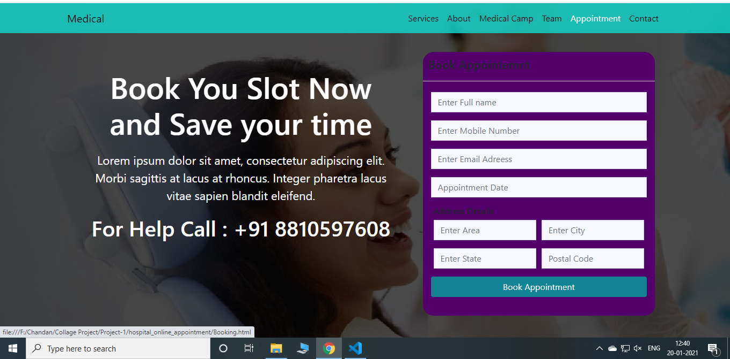

Coding:

<!--Booking Appointment-->
<div class="inner-layer">
<div class="container">
<div class="row no-margin">
<div class="col-sm-7">
<div class="content">
<h1>Book You Slot Now and Save your time</h1>
<p>Lorem ipsum dolor sit amet, consectetur adipiscing elit. Morbi sagittis at lacus at rhoncus. Integer pharetra lacus vitae sapien blandit eleifend. </p>
<h2>For Help Call : +91 8810597608</h2>
</div>
</div>
<div class="col-sm-5">
<div class="form-data">
<div class="form-head">
<h2>Book Appointemnt</h2>
</div>
<div class="form-body">
<div class="row form-row">
<input type="text" placeholder="Enter Full name" class="form-control">
</div>
<div class="row form-row">
<input type="text" placeholder="Enter Mobile Number" class="form-control">
</div>
<div class="row form-row">
<input type="text" placeholder="Enter Email Adreess" class="form-control">
</div>
<div class="row form-row">
<input id="dat" type="text" placeholder="Appointment Date" class="form-control">
</div>

<h6>Address Details</h6>

<div class="row form-row">
<div class="col-sm-6">
<input type="text" placeholder="Enter Area" class="form-control">
</div>
<div class="col-sm-6">
<input type="text" placeholder="Enter City" class="form-control">
</div>
</div>
<div class="row form-row">
<div class="col-sm-6">
<input type="text" placeholder="Enter State" class="form-control">
</div>
<div class="col-sm-6">
<input type="text" placeholder="Postal Code" class="form-control">
</div>
</div>

<div class="row form-row">
<button class="btn btn-success btn-appointment">
Book Appointment
</button>

</div>

</div>
</div>
</div>
</div>
</div>
</div>
<!--End of Booking Appointment-->

How Connection implement VB6.0 with MS Access

Firstly we have to open to ms accesss and then click on blank database and a dialog appear to save the database mdb file and save in drive database folder type the database name amy one you can create and click create .

Create table using first option . Create table in design view and double click on it.Type the field names and their Date types .Then save table with name +_info Add records according to the fields for demonstration purpose . doube click on the table to view the data.close MS ACCESS

Open vb 6.0 First add ADODC Control in to the form . Two ways by clicking on Project manu and further select components sub menu or Right click on the toolbox

Click on Project Menu and go to reference then select Microsoft ADO 6.0 Library then click ok.Right click on toolbox and Select Microsoft ADO Data Control 6.0 Microsoft Common Dialog Control 6.0 Microsoft Common Control 2 6.0 and Click apply and close.Now controls are available for use.

Then create a form and take an ADO button on it then click on ADODC Control and drag it on to the form.

Now go to the property wndow of ADODC Control and set the following properties.
Name: Studentdb
Captions:Studewnt Database

Click on Connection String Property and Click on Browse… button

A Dialog “Property Page” will appear on the screen.Click on Radio Button “ Use Connection String “ AND Click on Build Button.

Another Dialog “Data Link Properties “will appear on the screen In provider Tab Select Microsoft Jet 4.0 OLEDB Provider and Click NEXT>>

Browse your database from the Drive by clicking on browse button……

Click on Test Connection You Will get message “Test Connection Succeeded”, Click OK.

Now Click Apply and Press OK.

Click on Record Source Property and Press Browse Button.

Again Property Pages Dialog Appears. IN Command type , Select 2-adcmd Table from dropdown list and from Table or stored ,Procedure Name Select Table name (Name Appers automatically),
Then click on Apply and Press OK.

Add one label on to form set Caption”Name of form ”Align:Center” Font : As per your choice, Insert text box adjacent to the Roll no Label.Repeat the same step to add Labels and Textboxes according to fields of database table .

Click on Text Box Adjacant to set the following properties. Text : blank Data Sources and Data
Fields will be automatically appear and Select it from Drop down list.

Appply Fonts to all Labels and Textbox control by selecting the control and using font property.

Click f5 to run. Here you can see the data which is stored in our database . you see easily move between the records by pressing the button on ADODC CONTROL.Click on ADODC control and set Visible to False . Run the program and see your ADODC Control is not visible now.

Insert Command Buttons on to the form LIKE
First
Previous
Next
Last

Set the properties:
Change Caption and Name like
Caption : First Record , and Name : Firstbtn
Caption : Previous Record, and Name : prevbtn
Caption : Next Record , Name : Nxtbtn
Caption : Last Record , Name : Lstbtn

Apply font to each command button. Dounle click on Command Button. A code window appear on screen.
Private Sub Firstbtn_Click()
Studentdb.Recordset.MoveFirst
End Sub

Private Sub Prevbtn_Click()
Studentdb.Recordset.MovePrevious
End Sub

Private Sub Nxtbtn_Click()
Studentdb.Recordset.MoveNext
End Sub

Private Sub Lstbtn_Click()
Studentdb.Recordset.MoveLasts
End Sub

ADO Connection with Microsoft Visual Basic

Setting up an ADO project and writing ADO code is similar whether you use Visual Basic or Visual Basic for Applications. This topic addresses using ADO with both Visual Basic and Visual Basic for Applications and notes any differences.

Referencing the ADO Library
The ADO library must be referenced by your project.

To reference ADO from Microsoft Visual Basic
- In Visual Basic, from the Project menu, select References....
- Select Microsoft ActiveX Data Objects x.x Library from the list. Verify that at least the following libraries are also selected:
  - Visual Basic for Applications
  - Visual Basic runtime objects and procedures
  - Visual Basic objects and procedures
  - OLE Automation
- Click OK.
You can use ADO just as easily with Visual Basic for Applications, by using Microsoft Access, for example.

To reference ADO from Microsoft Access
- In Microsoft Access, select or create a module from the Modules tab in the Database window.
- On the Tools menu, select References....
- Select Microsoft ActiveX Data Objects x.x Library from the list. Verify that at least the following libraries are also selected:
  - Visual Basic for Applications
  - Microsoft Access 8.0 Object Library (or later)
  - Microsoft DAO 3.5 Object Library (or later)
- Click OK.

Creating ADO Objects in Visual Basic
To create an automation variable and an instance of an object for that variable, you can use two methods: Dim or CreateObject.

Dim
You can use the New keyword with Dim to declare and create instances of ADO objects in one step:
Dim conn As New ADODB.Connection
Alternatively, the Dim statement declaration and object instantiation can also be two steps:
Dim conn As ADODB.Connection
Set conn = New ADODB.Connection
Note
It is not required to explicitly use the ADODB progid with the Dim statement, assuming you have correctly referenced the ADO library in your project. However, using it ensures that you will not have naming conflicts with other libraries.
Note
For example, if you include references to both ADO and DAO in the same project, you should include a qualifier to specify which object model to use when instantiating Recordset objects, as in the following code:
Dim adoRS As ADODB.Recordset
Dim daoRS As DAO.Recordset

CreateObject
With the CreateObject method, the declaration and object instantiation must be two discrete steps:
Dim conn1
Set conn1 = CreateObject("ADODB.Connection") As Object
Objects instantiated with CreateObject are late-bound, which means that they are not strongly typed and command-line completion is disabled. However, it does allow you to skip referencing the ADO library from your project, and enables you to instantiate specific versions of objects. For example:
Set conn1 = CreateObject("ADODB.Connection.2.0") As Object
You could also accomplish this by specifically creating a reference to the ADO version 2.0 type library and creating the object.

CONCLUSION

The system has been developed for the given condition and is found working effectively. The developed system is flexible and changes whenever can be made easy. Using the facilities and functionalities of php, the software has been developed in a neat and simple manner, thereby reducing the operators work.

The speed and accuracy are maintained in proper way. The user friendly nature of this software developed in php framework is very easy to work with both for the higher management as well as other employees with little knowledge of computer.

The results obtained were fully satisfactory from the user point of view.
The system was verified with valid as well as invalid data in each manner. the system is run with an insight into the necessary modifications that may require in the future. Hence the system can be maintained successfully without much network.

BIBLIOGRAPHY

The great help from our faculty members and my project guide that led the successful completion of the project. Besides that, I took the help of some books and websites to develop the project. They are : --

1. VISUAL BASIC BLACK BOOK
--- Steven Holzner

2. MASTERING VISUAL BASIC 6.0
---- Evangelos Petroutsos

SITES :

- www.a1vbcode.com
- www.google.co.in

THANK YOU

